This document is partly adapted from an edited version of Tony R. Kuphaldt's 'Lessons In Electric Circuits series of textbooks on the subjects of electricity and electronics (Copyright (C) 2000-2020,) which allow for free copying, distribution, and/or modification by the general public.

Foreword

I'm going to skip a lot of detail simply because i'm trying to fast forward you to the useful stuff.
I'm assuming you're not trying to build a transistor, design anything requiring difficult mathematics, design a complex circuit or even connect up anything affected by the more complex aspects of current/voltage/electrons.

I am writing this in case you want to do more than just randomly plug wires into modules, specifically logic, sequencing and switching modules.
I am also writing this for those who may want to make modifications to RYO modules or to build expanders to RYO modules with expansion headers or pads for adding expansion options.

As such there's a mixture of basic information on how logic works, electronic logic works, more complex components built of logic, and more complex components built of those components work.
This goes right up to near the level of how full blown computers work (not in extreme detail) so as to cover how the most complex RYO modules like the VC Sequencer work, both theoretically and practically.

This also might provide inspiration for some of the more adventurous wigglers of modular synths to build patches involving whole serge style patch programmable, complex, multiple module assemblies that have higher order functions similar to some of the computer parts or even simple computers described later in this document.

Contents and Why

- Transistors (only a little info) because RYO logic modules, the more complex RYO modules, and computers are built of or based on parts built of them.
- Logic Theory (and a little of the electronics - no math here) and because RYO's simplest modules are the logic modules and the concepts allow grasping of the more complex part of sequencers and computers.
- Combinational Logic because it explains specifically the operation and building of encoders/decoders, multiplexers and some other stuff used in RYO modules and computers.
- Sequential logic and multivibrators, as above because both go to explain how the stuff used in some RYO modules and computers work, specifically counters and shift registers.
- some types of DAC's and ADC's because they are used in the RYO VC Seq, some other parts of RYO sequencing, logic and switching modules and also in certain computing and audio applications.

Bipolar transistors

The simplest form of transistor to understand is the bipolar junction transistor. For our purposes, all you really need to be aware of (vaguely), is the following:

The three leads of a bipolar transistor are called the Emitter, Base, and Collector.

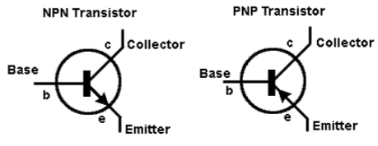

- Transistors function as current regulators by allowing a small current to control a larger current.

- The amount of current allowed between collector and emitter is primarily determined by the amount of current moving between base and emitter.

Note, currents go against the emitter arrow symbol.

- When a transistor has zero current through it, it is said to be in a state of cutoff (fully nonconducting).
- When a transistor has maximum current through it, it is said to be in a state of saturation (fully conducting).

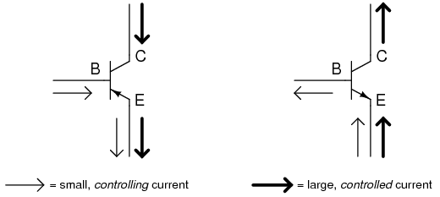

logic

In this circuit, the transistor is in a state of saturation by virtue of the applied input voltage (5 volts) through the two-position swi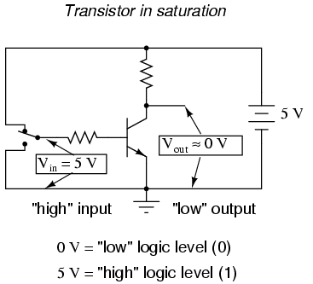

- the saturated transistor drops very little voltage between collector and emitter, resulting in an output voltage of (practically) 0 volts.

- If we were using this circuit to represent binary bits, we would say that the input signal is a binary "1" and that the output signal is a binary "0".

- Any voltage close to full supply voltage (measured in reference to ground, of course) is considered a "1" and a lack of voltage is considered a "0".

- Alternative terms for these voltage levels are high (same as a binary "1") and low (same as a binary "0").

- A general term for the representation of a binary bit by a circuit voltage is logic level.

- Moving the switch to the other position, applying a binary "0" to the input we receive a binary "1" at the output:

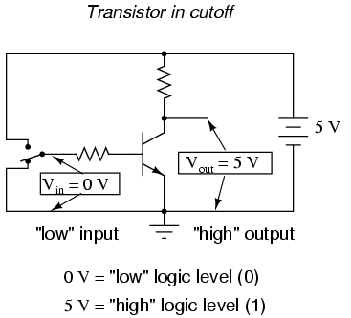

- What we've created here with a single transistor is a circuit generally known as a logic gate, or simply gate.

- The gate shown here with the single transistor is known as an inverter, or NOT gate, because it outputs the exact opposite digital signal as what is input.

- For convenience, gate circuits are generally represented by their own symbols rather than by their constituent transistors and resistors.

- The following is the symbol for an inverter:

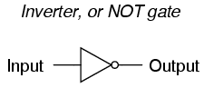

- One common way to express the particular function of a gate circuit is called a truth table.

- Truth tables show all combinations of input conditions in terms of logic level states (either "high" or "low," "1" or "0," for each input terminal of the gate), along with the corresponding output logic level, either "high" or "low."

- For the inverter, or NOT, circuit just illustrated, the truth table is very simple indeed:

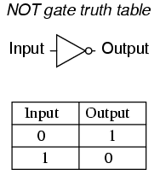

Other Gates

- Two inverter, or NOT, gates connected in "series" so as to invert, then re-invert, a binary bit perform the function of a buffer.

- Buffer gates merely serve the purpose of signal amplification: taking a "weak" signal source that isn't capable of sourcing or sinking much current, and boosting the current capacity of the signal so as to be able to drive a load.

- Buffer circuits are symbolized by a triangle symbol with no inverter "bubble.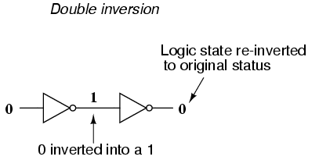

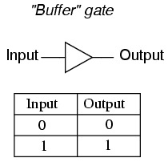

- Adding more input terminals to the circuit(s) gives more logic gate possibilities:

- With a single-input gate such as the inverter or buffer, there can only be two possible input states: either the input is "high" (1) or it is "low" (0).

- A two input gate has four possibilities (00, 01, 10, and 11).

The AND gate

- One of the easiest multiple-input gates to understand is the AND gate,

- The output of the AND gate will be "high" (1) if and only if all inputs (first input and the second input) are "high" (1).

- If any input(s) are "low" (0), the output is guaranteed to be in a "low" state as well.

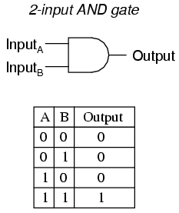

The NAND gate

- The NAND gate is a variation on the idea of the AND gate.

- The word "NAND" is a verbal contraction of the words NOT and AND.

- Essentially, a NAND gate behaves the same as an AND gate with a NOT (inverter) gate connected to the output terminal.

- To symbolize this output signal inversion the NAND gate symbol has a bubble on the output line.

- The truth table for a NAND gate is as one might expect, exactly opposite as that of an AND gate:

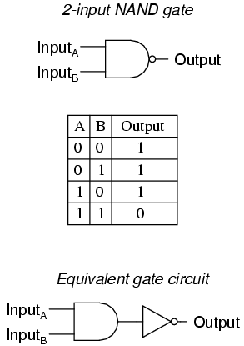

- As with AND gates, NAND gates are made with more than two inputs. In such cases, the same general principle applies:

- The output will be "low" (0) if and only if all inputs are "high" (1).

- If any input is "low" (0), the output will go "high" (1).

TTL

- Real inverter circuits contain more than one transistor to maximize voltage gain (so as to ensure that the final output transistor is either in full cutoff or full saturation), and other components designed to reduce the chance of accidental damage.

- Shown here is a schematic diagram for a real inverter circuit, complete with all necessary components for efficient and reliable operation:

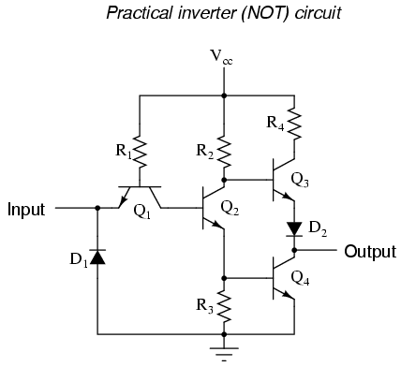

- Gate circuits constructed of resistors, diodes and bipolar transistors as illustrated in this section are called TTL.

- TTL is an acronym standing for Transistor-to-Transistor Logic.

- Suppose we altered our basic inverter circuit, adding a second input terminal just like the first:

(A simple transistor structure is inadequate to simulate the three junctions necessary in this network), so a different transistor (and symbol) is needed;

This transistor has one collector, one base, and two emitters like this: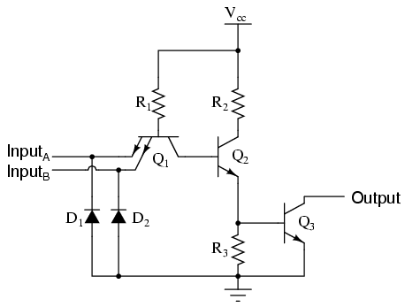

- The only difference to the simple inverter circuit is a second input terminal connected in the same way to the base of transistor Q2.

- We can say that each of the inputs will have the same effect on the output,

- i.e. if either of the inputs are grounded, transistor Q2 will be forced into a condition of cutoff, thus turning Q3 off and the output goes "high".

- In any case where there is a grounded ("low") input, the output is guaranteed to be "high".

- Conversely, the only time the output will ever go "low" is if transistor Q3turns on, which means transistor Q2 must be turned on (saturated).

- This means neither input can be diverting R1 current away from the base of Q2. The only condition that will satisfy this requirement is when both inputs are "high".

- Collecting and tabulating these results into a truth table, we see that the pattern matches that of the NAND gate:

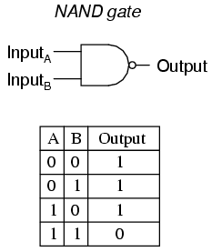

- In other words, a TTL NAND gate can be made by taking a TTL inverter circuit and adding another input.

- Consequently, An AND gate may be created by adding an inverter stage to the output of the NAND gate circuit.

OR Gates

- The OR gate is so-called because the output of this gate will be "high" (1) if any of the inputs (first input or the second input) are "high" (1).

- The output of an OR gate goes "low" (0) if and only if all inputs are "low" (0).

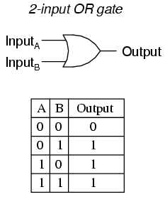

- Consequently the NOR gate is an OR gate with its output inverted, just like a NAND gate is an AND gate with an inverted output.

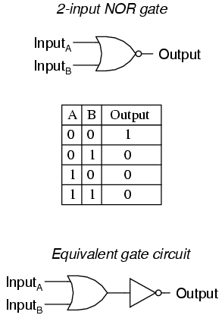

- Exclusive-OR gates output a "high" (1) logic level if the inputs are at different logic levels, either 0 and 1 or 1 and 0.

- Conversely, they output a "low" (0) logic level if the inputs are at the same logic levels.

- The Exclusive-OR (sometimes called XOR) gate has both a symbol and a truth table pattern that is unique:

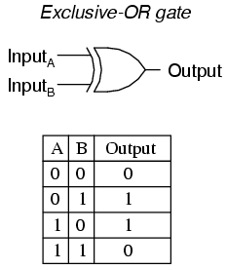

- The Exclusive-NOR gate, otherwise known as the XNOR gate is equivalent to an Exclusive-OR gate with an inverted output. T

- The truth table for this gate is exactly opposite as for the Exclusive-OR gate:

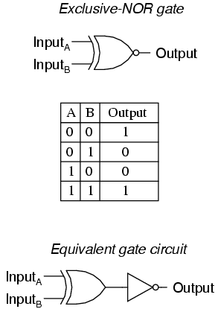

To sum up, the six most common and useful logic gates:

- An AND gate: output is "high" only if first input and second input are both "high"
- A NAND gate: output is not "high" if both the first input and the second input are "high"

- An OR gate: output is "high" if input A or input B are "high"
- A NOR gate: output is not "high" if either the first input or the second input are "high"

- An XOR gate: output is "high" if the input logic levels are different
- An XNOR gate: output is "high" if the input logic levels are the same

Combinational Logic

In mathematics a combination is an unordered set, which is a formal way to say that nobody cares which order the items came in.

With combinational logic, the circuit produces the same output regardless of the order the inputs are changed.

Combinational logic perform functions like arithmetic, logic, or conversion.
Each logic gate discussed previously is a combinational logic function.
Following, see how two NAND gates work if provided with inputs in different orders.
Beginning with both inputs being 0:

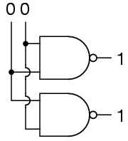

Then setting one input high:

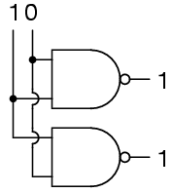

Then setting the other input high:

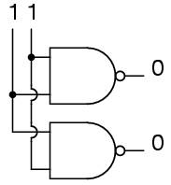

So NAND gates do not care about the order of the inputs, and the same is true of all the other gates covered up to this point (AND, XOR, OR, NOR, XNOR, and NOT).

A Half-Adder

(please note: the mathematics isn't fully essential in detail to understand this section – i've tried to ensure this is graspable from just the 'symbolic' representations of how-to-build useful logic devices/building blocks)

a quick note [or perhaps refresher] on binary mathematics:

- Instead of ten different cipher symbols we only have two cipher symbols,
- The two allowable cipher symbols for the binary system of numeration are "1" and "0".
- These ciphers are arranged right-to-left in doubling values of weight.
- The rightmost place is the ones place, just as with decimal notation.
- We refer to each cipher position in binary as a bit.

- The bit on the far right side is called the Least Significant Bit (LSB)
- The bit on the far left side is called the Most Significant Bit (MSB)

- A bit value of "1" means that the respective place weight gets added to the total value, and,
- A bit value of "0" means that the respective place weight does not get added to the total value.

Adding binary numbers is very similar to the longhand addition of decimal numbers:

- As with decimal numbers, start by adding the bits (digits) one column at a time, from right to left.

0 1 0
+ 0 + 0 + 1
- - -
0 1 1

- Also as with decimal addition, when the sum in one column is a two-bit (two-digit) number:
- The least significant figure is written as part of the total sum.
- The most significant figure is "carried" to the next left column.

1 1
+ 1 + 1
-- + 1
10 --
11

- These bits that are carried to the next column are called carry bits.
- Consider the following more complex examples:

<-- No 11 1 <---These bits -----> 11
1001101 carry 1001001 are 'carry' 1000111
+ 0010010 bits: + 0011001 bits: + 0010110
--------- follow --------- follow them ---------
1011111 down/along 1100010 down/along 1011101

- The addition problem on the left did not require any bits to be carried since the sum of bits in each column was either 1 or 0, not 10 or 11.
- In the other two problems, there definitely were bits to be carried – where columns added resulting in 10 or 11 then a 1 was carried to the next column and then the process was repeated in turn for that next column.

(As you may be now beginning to see, there are ways that electronic circuits can be built to perform this very task of addition, by representing each bit of each binary number as a either high [for a 1], or low [for a 0] voltage signal. This is the foundation of all the arithmetic which modern digital computers perform.)

- An example of useful combinational logic is a device that can add two binary digits together.

- calculating what the answers should be:

0 + 0 = 0 0 + 1 = 1 1 + 0 = 1 1 + 1 = 10

- So two inputs (a and b) and two outputs will be needed.

- The low output will be called Σ because it represents the sum, and the high output will be called Cout because it represents the carry out.

- The truth table is

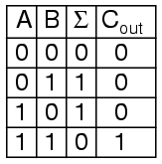

- looking at the results:

- The Σ column is an XOR gate, and,
- The Cout column is an AND gate.

- Therefore we can construct the device like so:

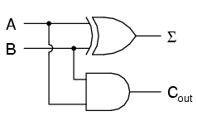

- This device is called a half-adder (for reasons that will make sense shortly).

A Full Adder

The half-adder is extremely useful until you want to add more that one binary digit quantities.

The slow way to develop a two binary digit adders would be to make a truth table and reduce it.
Then when you decide to make a three binary digit adder, do it again.
Then when you decide to make a four digit adder, do it again.
Then when ...

The circuits would be fast, but development time would be slow.

Looking at a two binary digit sum shows what we need to extend addition to multiple binary digits.
11
11
11
---
110
Look at how many inputs the middle column uses. Our adder needs three inputs; a, b, and the carry from the previous sum, and we can use our two-input adder to build a three input adder.
Σ is the easy part. Normal arithmetic tells us that if Σ = a + b + Cin and Σ1 = a + b, then Σ = Σ1 + Cin.
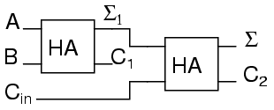
What do we do with C1 and C2? Let's look at three input sums and quickly calculate:
Cin + a + b = ?
0 + 0 + 0 = 0 0 + 0 + 1 = 1 0 + 1 + 0 = 1 0 + 1 + 1 = 10
1 + 0 + 0 = 1 1 + 0 + 1 = 10 1 + 1 + 0 = 10 1 + 1 + 1 = 11
If you have any concern about the low order bit, please confirm that the circuit and ladder calculate it correctly.
In order to calculate the high order bit, notice that it is 1 in both cases when a + b produces a C1. Also, the high order bit is 1 when a + b produces a Σ1 and Cin is a 1. So We will have a carry when C1 OR (Σ1 AND Cin). Our complete three input adder is:
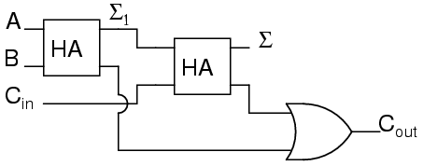

For some designs, being able to eliminate one or more types of gates can be important, and you can replace the final OR gate with an XOR gate without changing the results.

We can now connect two adders to add 2 bit quantities.
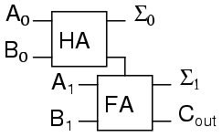

A0 is the low order bit of A, A1 is the high order bit of A, B0 is the low order bit of B, B1 is the high order bit of B, Σ0is the low order bit of the sum, Σ1 is the high order bit of the sum, and Cout is the Carry.
A two binary digit adder would never be made this way. Instead the lowest order bits would also go through a full adder.

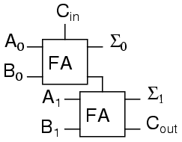

There are several reasons for this, one being that we can then allow a circuit to determine whether the lowest order carry should be included in the sum. This allows for the chaining of even larger sums. Consider two different ways to look at a four bit sum.
111 1<-+ 11<+-
0110 | 01 | 10
1011 | 10 | 11
----- - | ---- | ---
10001 1 +-100 +-101
If we allow the program to add a two bit number and remember the carry for later, then use that carry in the next sum the program can add any number of bits the user wants even though we have only provided a two-bit adder. Small PLCs can also be chained together for larger numbers.
These full adders can also can be expanded to any number of bits space allows. As an example, here's how to do an 8 bit adder.

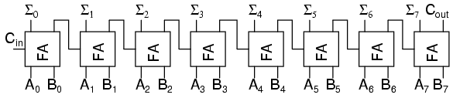

This is the same result as using the two 2-bit adders to make a 4-bit adder and then using two 4-bit adders to make an 8-bit adder or re-duplicating ladder logic and updating the numbers.

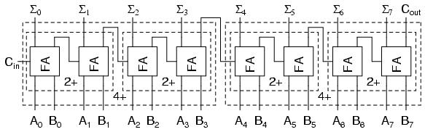

Each "2+" is a 2-bit adder and made of two full adders. Each "4+" is a 4-bit adder and made of two 2-bit adders. And the result of two 4-bit adders is the same 8-bit adder we used full adders to build.
For any large combinational circuit there are generally two approaches to design: you can take simpler circuits and replicate them; or you can design the complex circuit as a complete device.
Using simpler circuits to build complex circuits allows a you to spend less time designing but then requires more time for signals to propagate through the transistors. The 8-bit adder design above has to wait for all the Cxout signals to move from A0 + B0 up to the inputs of Σ7.
If a designer builds an 8-bit adder as a complete device simplified to a sum of products, then each signal just travels through one NOT gate, one AND gate and one OR gate. A seventeen input device has a truth table with 131,072 entries, and reducing 131,072 entries to a sum of products will take some time.
When designing for systems that have a maximum allowed response time to provide the final result, you can begin by using simpler circuits and then attempt to replace portions of the circuit that are too slow. That way you spend most of your time on the portions of a circuit that matter.

Sequential Logic

- There are circuits which depend on the when the inputs change, these circuits are called sequential logic.

- Sequential logic circuits make sure everything happens in order.

